|  |  |
| --- | --- |
| **Jurnal Humaniora Revolusioner** | JHR, 7 (12), Dec 2023  ISSN : 24475540 |

**ANALYSIS OF INDONESIAN SUPPORTER CHANT : RIVALRY, LOYALTY, FANATISM FROM INDONESIAN FOOTBALL CLUB**

**Ahmad Arasi Nurfalah1, Virga Putra Darma2**

**Email:**[arasinurfalah27@gmail.com1](mailto:arasinurfalah27@gmail.com1), virgaputradarma@gmail.com2

**Institut Prima Bangsa Cirebon**

**Abstrak**: Sepak bola merupakan salah satu olahraga yang digemari oleh semua orang di dunia. Dalam sepak bola, kehadiran suporter sangatlah penting dalam menunjang segala aktivitas yang ada dalam sepak bola. Suporter sering kali menyanyikan yel-yel atau lagu untuk menyemangati tim yang dibanggakan, namun itu semua berkaitan dengan kesetiaan, persaingan, dan fanatisme. Sepak bola Indonesia sendiri mempunyai rivalitas yang sangat kental begitu pula antara tim Persib, Persija, Persebaya, Arema. Penelitian ini menggunakan metode campuran antara kuantitatif dan kualitatif dengan pertanyaan-pertanyaan yang diberikan kepada koresponden untuk ditanggapi. Dengan penelitian ini juga mampu mengetahui hubungan antara bahasa dan sikap dalam cabang ilmu linguistik yaitu sosiolingusitik. Dengan menelaah penelitian ini dapat diketahui bahwa tingkat loyalitas sepakbola Indonesia sangat tinggi, selain itu rivalitas dan fanatisme banyak terjadi pada yel-yel sepakbola yang mengarah pada ujaran kebencian yang akan berujung pada konflik.

**Kata Kunci:** Nyanyian, Rivalitas, Loyalitas, Fanatisme, Sepak Bola.

**Abstract:** *Football is one of the sports that is loved by everyone in the world. In football, the presence of supporters is very important in terms of supporting all the activities that exist in terms of football. Supporters often sing chants or songs to cheer on a proud team but it all has to do with loyalty, rivalry and fanaticism. Indonesian football itself has a very thick rivalry as well as between the teams of Persib, Persija, Persebaya, Arema. This study used a mixed method between quantitative and qualitative with questions given to correspondents to respond. With this study is also able to determine the relationship between language and attitude in the branch of linguistics, namely sociolingusitics. By examining this study it can be found that the level of loyalty in Indonesian football is very high, in addition, rivalry and fanaticism are mainly occurring In football chants it leads to hate speech that will lead to conflict*

***Keyword:*** *Chant, Rivalry, Loyalty, Fanatism, Football.*

**INTRODUCTION**

Football is a game or sport that is very popular with people in all parts of the world. No wonder each country has its own football team. Football also has a world football organization, FIFA. Not just a sport, football also unites all aspects both socially and others.

Apart from football players, the presence of supporters is also important for the holding or holding of this football game. Supporter is support that comes from one or more people given to someone who is in a match with a sense of loyalty and love for the team his pride (Dhurkiem, 1988).

In supporting a pride team, there are many things or ways to support a pride team . One of them is by shouting or singing songs to encourage the players of their favorite team. Many chants or chants are made and shouted in the field or stadium, especially in Indonesian football.

Referencing Merriam-Webster, chant is making a melody with sound; to convey something in monotonously repetitive tones. Chant is repeating or singing a word or sentence continuously (Cambridge Advanced Learner's Dictionary &; Thesaurus, 2021).

Football chants or loud chants are catchy and easy-to-learn songs performed at football matches by fans. It is shouted and sung by supporters of a team, usually with the aim of provoking the enthusiasm of its fans and players (Parr, Freya, 2021).

Football chants are a part of language that consists of symbols or even spoken or written gestures used by humans to communicate with each other. People can share or communicate with others through songs. One of the things as a football fan is to use songs as a tool to express their support for their proud football club (Shodiq, Ihsan. M. 2020).

In the world of football supporters, especially in Indonesian football there are many rivalries that occur both on and off the field. When on the field, the rivalry that occurs is a very fierce match between teams when faced, for example, theethics of Persib Bandung VS Persija Jakarta. Games that are very intensive and have high tension can trigger an unhealthy rivalry. Persija Jakarta (The Jakmania) supporters and Persib Bandung (Viking) supporters often clash with each other. The rivalry between Jakmania and Viking occurred due to an incident off the field ahead of the 2000 Liga Indonesia match at home persib then replied by Persija supporters at the 2002 event (Samy, 2012).

Regarding the rivalry besides between Persib and Persija, there are also other clubs in the Indonesian league. Here also not only occurs because of clashes or heated tensions. Even this can happen because of shouting or chanting each other inside the stadium. Because of rivalry and the result of the loyalty of a group of supporters, making a group become fanatical which will cause friction that occurs, especially in chants or chants.

It is common to hear the word fanatic or fanaticism in news related to religion and sports, but it is rarely known what the true definition of the word "fanatic" is. If explored more deeply, actually the word fanatic in the big dictionary Indonesian means very strong belief (belief) in teachings (politics, religion, etc.). (Menik Purwandri Astuti 2011:28).

A behavior that is inseparable from the characteristics that make fanaticalbehavior are:

1. The existence of autism or excessive enthusiasm that is not based on common sense, but emotions. The absence of reason is what is very easy to make people fanatical about something, so they do things beyond normal.
2. 2. Broad-minded education, can lead to soldier attitude. Conversely, stunted or small education or indoctrination can lead to fanaticism.

(Menik Purwandri Astuti 2011:31)

As a result of loyalty, rivalry, and fanaticism in the world of football. It's interesting to analyze something in terms of lingusitics. One of the things that can be analyzed in football supporters is the song or chant of a group of supporters themselves, especially in Indonesian football.

The purpose of this study is to find out how much impact the chant or song performed by a group of supporters in terms of loyalty, rivalry, fanaticism. This study also aims to examine more about some things about 'taunting' or ridicule that is often done with the aim of provoking opponents. This study can also be studied more deeply in linguistic, psychological or sociological aspects of the attitude of Indonesian supporters.

**RESEARCH METHODS**

This research method uses a mixed method covering collection, analysis and integration of qualitative and quantitative data in single or phased studies (Hesse 2010). In this mixed research method by obtaining data, observing data, reviewing data , calculating data. All data obtained from online questionnaire questions or through online links. This study took data from correspondents where the correspondent or object of this study was given a questionnaire link. The correspondents in question are supporters of the Indonesian league team who understand or know the lyrics of the chant of their proud team. Furthermore, the results of filling out the questionnaire will be examined from the aspects of loyalty, rivalry, fanaticism. It will even be examined what words contain elements of hate speech or "taunting" contained in the lyrics or team chants that can result in The aspect in question appears.

Questions contained in the questionnaire include the following:

1. Does your pride team have a chant or a pride song?
2. If you have a chant or pride song, can it be an encouragement?
3. Give examples of rivalries in Indonesian football
4. Are you loyal to your proud club?
5. Can a chant or pride song be hate speech?
6. Can football supporters' chants cause division or conflict?
7. Anything and mention examples of hate words or speech in chants or pride songs

With this research, it is hoped that supporters of football teams, especially in Indonesia, do not do anarchic things due to chants that indicate ridicule or harsh words that mock each other. Which can be fatal and even the occurrence of loyalty, rivalry, fanaticism, which can make the origin of hatred even take someone's life.

**DISCUSSION**

In this study, it has been distributed and questioned the questionnaire to twelve correspondents consisting of several areas such as school or campus lings updifferent. This research can also find indications of how much violence or about loyalty, rivalry and fanaticism in defending a proud team. In this study, there are also words or sentences in chants or chant supporters that can cause conflict. This research is also sourced and refers to the study of linguistic branches, namely sociolinguistic about language and attitude. This research can also conclude between the relationship between chant and loyalty, rivalry, fanaticism between supporters, especially in Indonesia itself.

**Correspondents researched or observed**

|  |  |
| --- | --- |
| SCHOOL OR CAMPUS NAME | NUMBER OF CORRESPONDENTS |
| IPB Invada Cirebon | 6 |
| Institut Teknologi Sepuluh November | 1 |
| Institut Teknologi Nasional | 1 |
| Brawijaya University | 2 |
| SMA Negeri 4 Cirebon | 1 |
| SMP Negeri 4 Cirebon | 1 |

From the correspondents studied, it is clear that the supporters of the Indonesian pride team come from various regions. And if we have diverse correspondents, we can conduct research with diverse answers and be more objective in researching.

**Proud football team**

|  |  |
| --- | --- |
| TEAM NAME | NUMBER OF CORRESPONDENTS |
| Persib | 5 |
| Arema FC | 1 |
| Bhayangkara FC | 1 |
| Persebaya | 1 |
| Persija | 2 |
| Other | 2 |

Of the number of proud football teams of twelve correspondents, the most are occupied by Persib Bandung supporters. Then there are some supporters of the Indonesia football club and others. In this case, it will also affect the results of research, especially related to chants from each supporter.

All correspondents also gave answers about the rivalry that occurs in Indonesian football, this can also be related to rivalry that starts from loyalty and results in fanaticism. From all correspondents, replied compactly that between the Persib and Persija teams are the main rivals in Indonesia. A handful of correspondents also answered that Persebaya vs Arema is also among the main rivals in Indonesia. No wonder Persib, Persija, Persebaya, Arema are in the spotlight about rivalry. Because the team is big, and the bigotry of the supporters is the main thing to highlight.

**Does every team have a chant?**

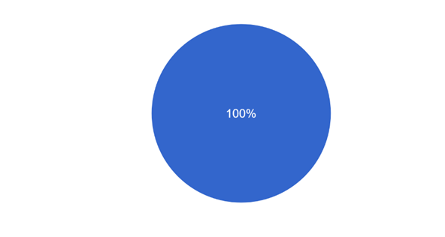

Blue : Yes

Red : No

From all the correspondents who answered, it is certain that every proud club has a chant to support a club, especially in Indonesia. With chants from all supporters, it indicates that chant supporters can be researched and can affect other factors, especially in this study.

**Can Chant be an encouragement?**

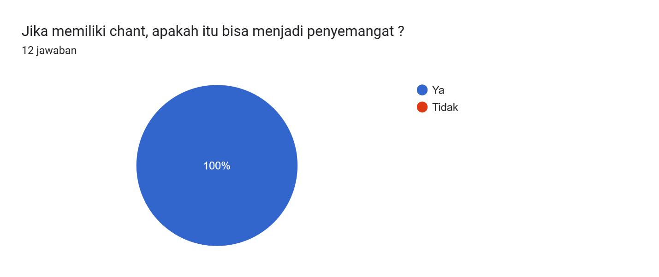

Blue : Yes

Red : No

Based on the results in the diagram above, all correspondents answered YES to chants can be team spirit or supporters. This is related to the meaning of the word supporter itself, which is to support something. Especially by shouting chants or songs in matches or outside matches. With chant being an encouragement, it can be interpreted that chant can bring an important impact to every team.

**Supporter loyalty**

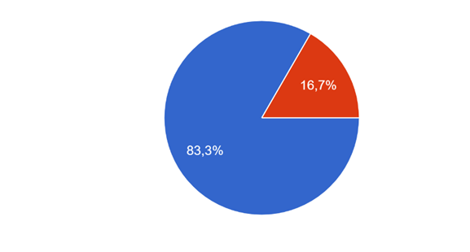

Blue : Loyal

Red : Not Loyal

We can see from the pie chart above, that loyalty to the club is very high, although there is a small number of correspondents who are not loyal to the club. From this we can see that supporter loyalty is also included in supporter loyalty to their proud team. It has been answered that the level of loyalty of supporters is very high from the proof that he has a chant for encouragement and about loyalty to a very high pride team.

**Hate speech in chants**

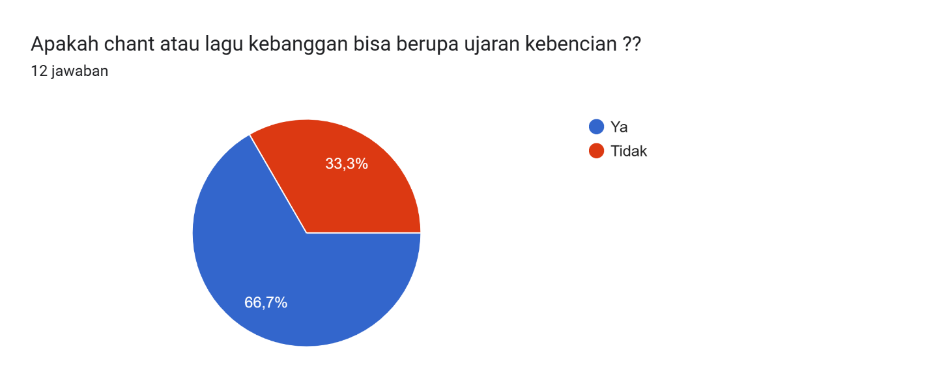

Blue : Chant use hate speech

Red : Chant not use hate speech

Hate speech in football supporter chants often occurs with it evident that in this diagram there are more than half of the correspondents answering that there is hate speech in the supporter chant. But there are also some correspondents who answer and think that in chants there are also chants that are not hate speech. This can also be the next benchmark in the influence of fanaticism that will lead to conflict, especially in hate speech

**As a result of conflict-causing hate speech**

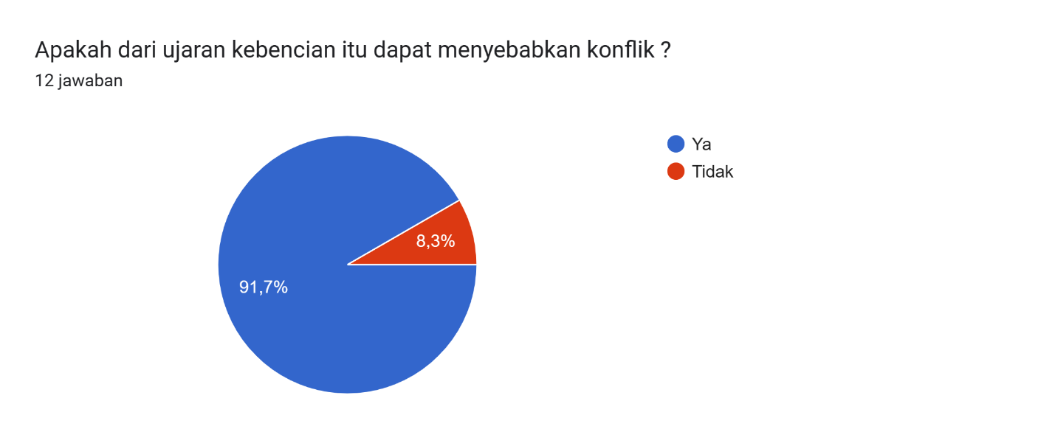

Blue : Hate speech can make conflict

Red : hate speech can not make conflict

As a result of the hatred contained in the chant or song of the supporter itself. Almost all correspondents replied YES hate speech would lead to conflict. It is clear that the fanfare of supporters, especially in Indonesia, is very high. Because hate speech or ' taunting' sung is contained in chants to mock opponents or make opponents angry with hate speech. Even hate speech that causes conflict itself can cause someone's death as explained in the introduction to this article

Examples of hate speech words or sentences

|  |  |  |  |
| --- | --- | --- | --- |
| No | MAIN WORD OR SENTENCE | MEANING | EXPLANATION |
| 1 | Persija anak papah | Persija as dady own | Chant or the nickname 'papah child' occurred because of an incident when the champion persija in 2018. Where many people speculate when the director of the company related to the bribery case. And the incident was associated with the champion Persija in 2018 which had many controversies until Persija benefited a lot from the field referee. |
| 2 | Jancok | Fuck (in Javanese) | This word is often used by East Javanese people specifically, to curse or be annoyed about something. Even during a football match, when a group of supporters are upset, the word 'jancok' will be said |
| 3 | Bajingan | Bastard | Similar to the word 'jancok' this word is commonly used to curse |
| 4 | The Jak anjing | The jak like a dog | This phrase was used by Persija opposition supporters to mock and even attack each other's chant 'taunting' |
| 5 | Dibunuh saja | Kill him | This sentence is actually a continuation of the chant 'the jak anjing' which is continued with this sentence. As if the persija supporter was eradicated and useless |
| 6 | The jak tai anjing | The jak a dog shit | This phrase is also used by opponents of Persija fans. By giving this chant, there will be a fight of hate speech. Even to the point of causing physical disputes between the two sides. |
| 7 | Macannya jadi kucing | Tiger become a cat | Thislimat is intended so that the mentality of the players on the field and the fans are ignited by emotions. The word 'tiger' itself is taken from Persija's lambing or mascot . When Persija in the match suffered a defeat. So it is considered that the 'tiger' turned into a helpless lackey. |
| 8 | "Siapa bilang Indonesia Arema, Itu orang yang ga pernah sekolah" | Talk about who say "Indonesian Arema own" that's no have knowledge" | Kalimat aims to express hatred towards the Arema FC team or supporters who consider Indonesia to be entirely Arema . Also they are considered fools and never go to school |
| 9 | "Jantung paru-paru tenggorokan. Viking mlayu-mlayu bli sempakan” | Herat and troth, viking run do not use underwear | This sentence is unique, because it comes from the regional language, namely Cirebon (Javanese) where this sentence is only a tauniting so that supporters of Vikings' special opponents go down. |

From some examples of hate speech and 'taunting' to supporters or opposing teams. There is a lot of hate speech, especially in terms of the rivalry that occurs between Persib vs Persija and its supporters, namely The Jak and Vikings who have swear words, hate speech and "taunting" in it. This shows that chants can affect the rivalry of a person or group. It is based on the diagram above that speech can also affect or arise conflict. There have been several examples of words in existing chants or songs. It is also prone to conflict due to the loyalty and bigotry of the supporters themselves.

**CONCLUSION**

From the title presented in this study, it focuses on how chant supporters influence in the level of loyalty, rivalry, fanaticism in Indonesian football supporters . This study or research also focuses on the branch of lingusitics that examines how chants or words affect attitude (language of attitude). Also When you already know about the language of attitude in chant or supporter itself, then this study is related to rivalry, loyalty, fanaticism due to the influence of chant words itself. From all the questionnaire questions to the correspondents, it can be concluded that supporters from various Indonesian teams strongly agree that Chant can influence the loyalty and bigotry of a group of Ters. And it can also be concluded that the rivalry that occurs in Indonesian football itself affects or is influenced by chant supporters which are in the form of hate speech. Then which is included in sociolinguistic studies is about language towards attitude.

The rivalry between Persija and Persib supporters is also a great example that rivalry can make people loyal and fanatical even to the point of making chants containing hate speech. Where hate speech is mutually linked between groups of Persib supporters or Persija. In other words, Chant supporters are very influential in terms of loyalty, rivalry, fanaticism. By knowing the very high level of hate speech, we must refer to sociolinguistic science, namely the language of attitude where we have an attitude in language, then we will avoidance of conflict. This research is also focused so that conflicts that occur in Indonesian football in particular can be minimized or even eliminated. With chant supporters who build enthusiasm, use language based on attitude and do not cause conflict. Hopefully there will be no casualties again due to the bigotry of Indonesian supporters. So speak the language well

**REFERENCES**

Astuti, Menik Purwandari, 2011. The relationship between fanaticism towards idols and imitation in teenagers.

Cambridge Advanced Learner's Dictionary &; Thesaurus. Chant.

Iqni Malfaid, 2013. Fanaticism of football fans to instill social solidarity.

Merriam-Webster. (n.d.). Chant. In Merriam-Webster.com dictionary.

Parr, Freya, 2021. The best football chants based on classical music.

Sammy, A. (2012). Embers behind football costumes.

Sarwono Jonatan, 2011. Mixed Methods: How to Combine Quantitative Research and Qualitative Research Correctly.

Shodiq, Ihsan. M. 2020. Type And Meaning Of Figurative Language Of Most Popular Football Anthem Song From English Premier League Club.

Sihombing Lambok, Aristia Andhien, Bumi Lanang, 2021. Song Of The Spirit In The Jak Mania Chants: Tribute From Fans To Footballers.